Session 8

- Write a Python function calculate_probability(event_count, total_outcomes) that returns the probability of an event, and use it to find the probability of getting 'Heads' when tossing a coin.

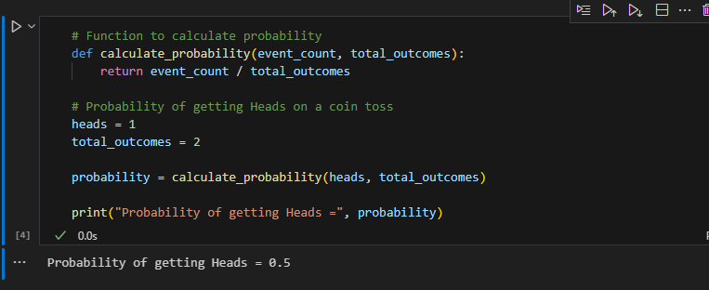
- Simulate rolling a six-sided dice 100 times using Python's random module, count how many times a '6' appears, and calculate the experimental probability of getting a '6'.<br><br><em><strong>Hint:</strong> Use random.randint(1,6) in a loop and keep a counter for '6'.</em>.
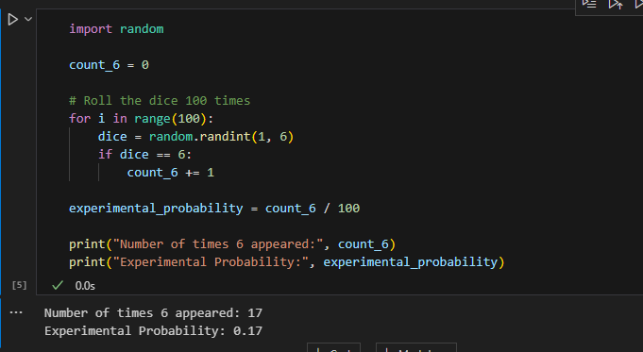
- Given an array of genres from your last 20 Spotify songs (like ['pop', 'rock', 'pop', 'hiphop', ...]), write code to calculate the probability of randomly picking a 'pop' song from your recent history.
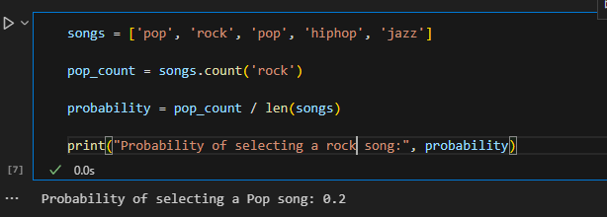
- Write a function that, given two arrays — one for users who ordered food on Zomato and one for users who ordered dessert — calculates the probability that a randomly selected user ordered both food and dessert (i.e., intersection over total unique users).
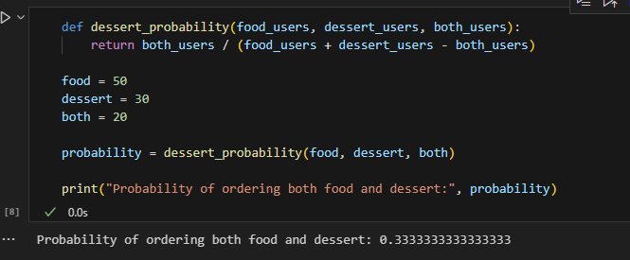
- Explain with a short Python code example how conditional probability could be used to improve recommendations in an app like Flipkart (e.g., probability of buying headphones given user bought a phone).<br><br><em><strong>Hint:</strong> Use counts of users who bought both items vs total who bought a phone.</em>
